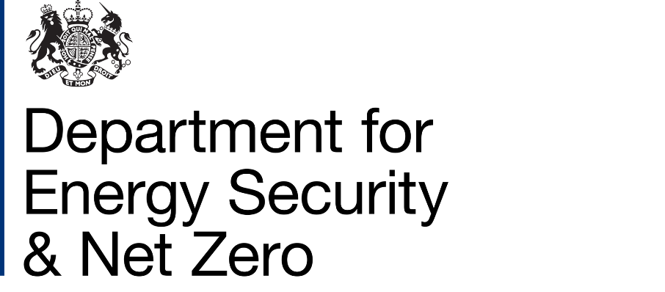

**Social Housing Decarbonisation Fund Wave 2.2 Privacy Notice**

This notice sets out how the Department for Energy Security and Net Zero (DESNZ) will use your personal data relating to the Social Housing Decarbonisation Fund Wave 2.2 (SHDF – Wave 2.2), and your rights. It is made under Articles 13 and/or 14 of the UK General Data Protection Regulation (UK GDPR). This notice relates to data collected under SHDF – Wave 2.2, operated by successful applicants to the scheme and funded by DESNZ.

**Your data**

**The data**

We (DESNZ), and DESNZ’ delivery and research partners, will process the following personal data:

**Households offered installations under SHDF – Wave 2.2**

* address and details of the property receiving SHDF – Wave 2.2 installations
* details about the SHDF – Wave 2.2 installations at the property, including type, size, cost, and installer details
* address and details of properties offered, but not receiving, SHDF – Wave 2.2 installations
* your name and contact details (address, email and phone number)
* if relevant, the amount of funding the household contributed towards SHDF - Wave 2.2 installations

**Installers**

* your name and contact details (business contact address, business email address and business phone number)
* relevant accreditation and registration information, such as Trustmark or MCS license numbers, and Companies House Company Registration Numbers
* details of SHDF installations delivered (including cost and address)
* whether directly contracted or sub-contracted by a Social Housing Landlord to install SHDF – Wave 2.2 installations

**Registered Providers of social housing and Registered Charities**

* names and business contact details (address, email, and phone number) of Social Housing Landlords, their employees, and their delivery partners, involved in preparing and submitting an application under SHDF – Wave 2.2
* names and business contact details (address, email, and phone number) of employees of Social Housing Landlords, and their delivery partners involved or proposed to be involved in the implementation of an application if it is successful

**Purpose**

We process your personal data to support the delivery and administration of SHDF – Wave 2.2.

We obtain your personal data from Grant Recipients of SHDF – Wave 2.2. Data may also be obtained from TrustMark, Ofgem, other government departments and from other organisations administering central or local government schemes that support energy efficiency or low-carbon heating measures.

Delivery and administration of the scheme may require linking of your data to other datasets held by DESNZ.

Your data may also be used for statistical, research, or fraud prevention purposes.

DESNZ will conduct an evaluation of the scheme to understand its impacts and effectiveness. This may include you being contacted by DESNZ or its research partners to take part in research. Where this evaluation research involves processing of personal data in addition to that already collected for delivery of the Scheme, you will be given the opportunity to opt-in to that research at the point of contact (relying on consent). This processing will be the subject of a separate Privacy Notice. In practice this means that our evaluation contractor may call, email or write to you to invite you to take part in a survey or interview, as well as provide you with more information about what the research will involve.

**Legal basis of processing**

The legal basis for processing your personal data is:

* **Public task**

Processing is necessary for the performance of a task carried out in the public interest. The public tasks are outlined above and include the delivery, administration, audit and evaluation of SHDF – Wave 2.2.

This data will be used to ensure use of public funds has delivered value for money, and realised intended benefits, including to inform policy making in the fields of energy efficiency, fuel poverty, and health. It will also support DESNZ’ functions relating to carbon reductions under the Climate Change Act 2008.

**Recipients**

Your personal data will be shared with:

* the Department for Energy Security and Net Zero
* appointed delivery and research partners for SHDF – Wave 2.2
* DESNZ contractors and other government departments

Your personal data is shared to support in the delivery, administration, and evaluation of the scheme, for statistical, research and fraud prevention purposes, and to inform the development of government policy.

We may share your data if we are required to do so by law, for example by court order or to prevent fraud or other crime.

Personal data collected by DESNZ will be securely stored on their IT (Information Technology) infrastructure and will therefore also be shared with their data processors Microsoft and Amazon Web Services.

**Retention**

Your personal data will be stored securely by DESNZ for a maximum period of 7 years following the close of the Scheme or, if later, the completion of installations funded under the Scheme, for the delivery, administration and evaluation of the scheme, as well as for fraud prevention purposes.

**Your rights**

You have the right to request information about how your personal data are processed, and to request a copy of that personal data.

You have the right to request that any inaccuracies in your personal data are rectified without delay.

You have the right to request that any incomplete personal data are completed, including by means of a supplementary statement.

You have the right to request that your personal data are erased if there is no longer a justification for them to be processed.

You have the right in certain circumstances (for example, where accuracy is contested) to request that the processing of your personal data is restricted.

You have the right to object to the processing of your personal data where it is processed for direct marketing purposes.

You have the right to object to the processing of your personal data.

You have the right to request a copy of any personal data you have provided, and for this to be provided in a structured, commonly used, and machine-readable format.

**How to make a request**

If you wish to make a request associated with any of the rights listed above, contact DESNZ using the contact details at the bottom of this notice.

**International transfers**

Your data will be processed in the UK.

**Contact details**

Once your personal data has been shared with DESNZ or with its delivery partners, DESNZ will become a data controller for that personal data. If you wish to make a request associated with any of the rights listed above and in relation to personal data shared with DESNZ or with DESNZ delivery partners/agents, you may contact DESNZ using the following contact details.

DESNZ Data Protection Officer  
Department for Energy Security and Net Zero  
3-8 Whitehall Place

London  
SW1A 2EG  
Email: [dataprotection@energysecurity.gov.uk](mailto:dataprotection@energysecurity.gov.uk)

**Complaints**

If you consider that your personal data has been misused or mishandled, you may make a complaint to the Information Commissioner, who is an independent regulator. The Information Commissioner can be contacted at:

Information Commissioner's Office  
Wycliffe House  
Water Lane  
Wilmslow  
Cheshire  
SK9 5AF  
0303 123 1113  
[https://ico.org.uk/make-a-complaint/](https://eur02.safelinks.protection.outlook.com/?url=https%3A%2F%2Fico.org.uk%2Fmake-a-complaint%2F&data=05%7C01%7CRosalind.Firth%40beis.gov.uk%7C5f2ad921336a48a4bae108db6dac4026%7Ccbac700502c143ebb497e6492d1b2dd8%7C0%7C0%7C638224358791065989%7CUnknown%7CTWFpbGZsb3d8eyJWIjoiMC4wLjAwMDAiLCJQIjoiV2luMzIiLCJBTiI6Ik1haWwiLCJXVCI6Mn0%3D%7C3000%7C%7C%7C&sdata=r1R5wmRKsRZjHF2B2ADKjWiQSzNrbofRgp69LpQXSQg%3D&reserved=0)

Any complaint to the Information Commissioner is without prejudice to your right to seek redress through the courts.